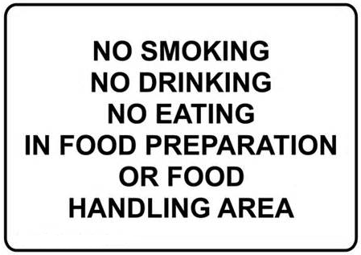
Employees may consume food only in designated dining areas.
-This area shall be separate from food preparation and storage areas.

Employee beverages shall be in a closed container away from food preparation and storage areas to prevent contamination of employee’s hands, exposed food, equipment, and utensils.

