Thawing Potentially Hazardous Foods
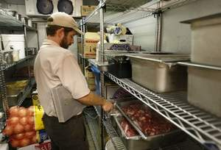
- In refrigerated units in a way that the temperature of the food does not exceed 41⁰ F.

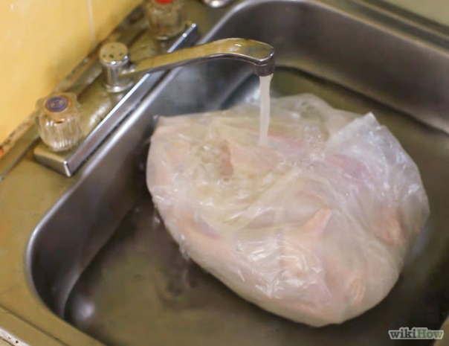
- Under potable running water at a temperature of 70⁰ F or below, with sufficient water velocity to agitate and float off loose food particles into the overflow.

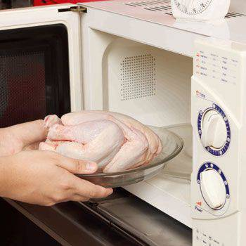
- In a microwave oven only when the food will immediately transferred to conventional cooking facilities as a part of continuous cooking process or when the entire, uninterrupted cooking process takes place in a microwave.

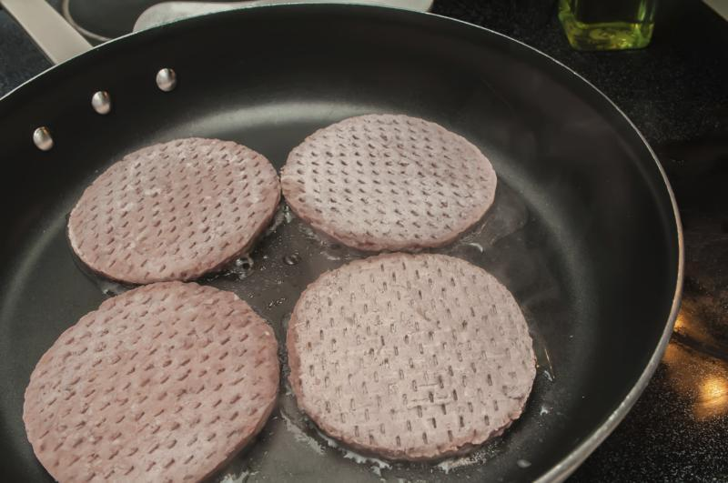

- As part of the conventional cooking process.

